SUBMITTED BY:

Shimonee Singh(RA1911003011052)

EXPERIMENT-3

GRAPH VERTEX AND EDGE COLORING PROBLEM

Code:

class graph:

       def __init__(self,edges,n):

         self.adj=[[] for _ in range(n)]

         for(src,dest)in edges:

            self.adj[src].append(dest)

            self.adj[dest].append(src)

def color_graph(graph):

   result={}

   for u in range(n):

     assigned=set([result.get(i) for i in graph.adj[u]if i in result])

     color=1

     for c in assigned:

       if color!=c:

         break

       color= color+1

     result[u]=color

   for v in range(n):

    print("COLOR ASSIGNED TO VERTEX",v,"is",colors[result[v]])

   print("\n")

   for v in range(n):

    print("COLOR ASSIGNED TO EDGE",v,"is",colors[result[v]+3])

if __name__=='__main__':

  colors=["","YELLOW","BLACK","GREEN","PURPLE","BROWN","RED","BLUE","WHITE","VIOLET","ORANGE","PINK"]

  edges=[(0,1),(1,2),(2,3),(3,4),(4,5),(5,6),(6,0)]

  n=7

  Graph=graph(edges,n)

  color_graph(Graph)

OUTPUT:

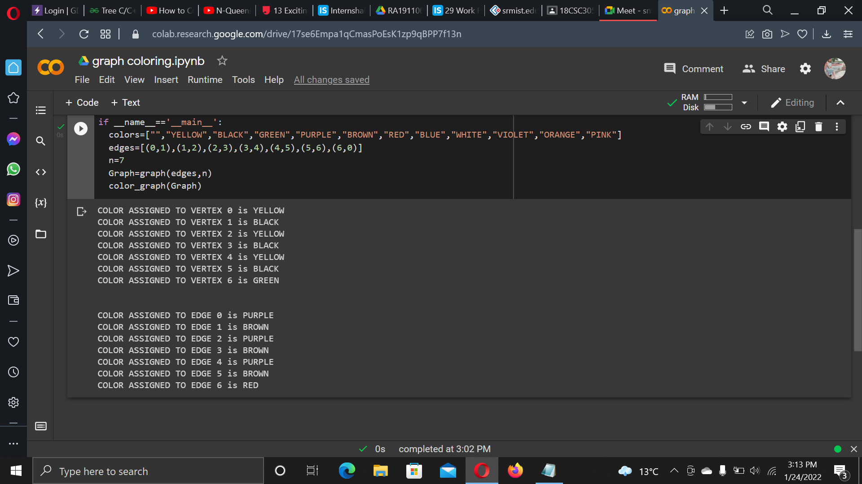

CONCLUSION:

The output for graph coloring problem has been executed.